[](http://www.thecompletistgeek.com/tarzan.htm)

[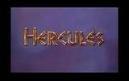](http://www.thecompletistgeek.com/hercules.htm)

[](http://www.thecompletistgeek.com/mulan.htm)

[](http://www.thecompletistgeek.com/pocahontas.htm)

[](http://www.thecompletistgeek.com/thelionking.htm)

[](http://www.thecompletistgeek.com/aladdin.htm)

[](http://www.thecompletistgeek.com/beautyandthebeast.htm)

[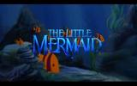](http://www.thecompletistgeek.com/thelittlemermaid.htm)

[](http://www.thecompletistgeek.com/oliverandcompany.htm)

[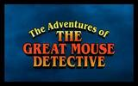](http://www.thecompletistgeek.com/thegreatmousedetective.htm)

[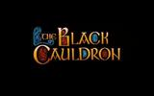](http://www.thecompletistgeek.com/theblackcauldron.htm)

[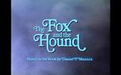](http://www.thecompletistgeek.com/thefoxandthehound.htm)

[](http://www.thecompletistgeek.com/therescuers.htm)

[](http://www.thecompletistgeek.com/themanyadventuresofwinniethepooh.htm)

[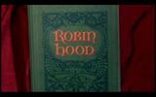](http://www.thecompletistgeek.com/robinhood.htm)

[](http://www.thecompletistgeek.com/thearistocats.htm)

[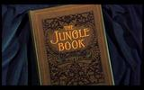](http://www.thecompletistgeek.com/thejunglebook.htm)

[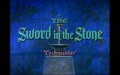](http://www.thecompletistgeek.com/theswordinthestone.htm)

[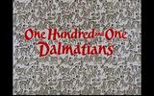](http://www.thecompletistgeek.com/101dalmatians.htm)

[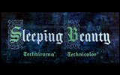](http://www.thecompletistgeek.com/sleepingbeauty.htm)

[](http://www.thecompletistgeek.com/ladyandthetramp.htm)

[](http://www.thecompletistgeek.com/peterpan.htm)

[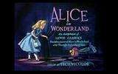](http://www.thecompletistgeek.com/aliceinwonderland.htm)

[](http://www.thecompletistgeek.com/cinderella.htm)

[](http://www.thecompletistgeek.com/thethreecaballeros.htm)

[](http://www.thecompletistgeek.com/saludosamigos.htm)

[](http://www.thecompletistgeek.com/bambi.htm)

[](http://www.thecompletistgeek.com/dumbo.htm)

[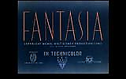](http://www.thecompletistgeek.com/fantasia.htm)

[](http://www.thecompletistgeek.com/pinocchio.htm)

[](http://www.thecompletistgeek.com/snowwhiteandthesevendwarfs.htm)