Come join Ms. Arty Pants for a fun afternoon of

painting at Hazelwood Elementary School!

**When:** Friday, December 8 at **1:00p.m. till 2:30**

***Who: Pre-K -2nd graders***

***This event will occur during school hours. Your child will go home at the end of the day as usual!***

**Cost:** $10.00 for 8X10 canvas pre-sketched picture.

(**NO REFUNDS** and paintings will be distributed the following week)

*Students may select multiple pictures.*

**Make Checks Payable to Hazelwood PTO**

PTO Plott Hound Christmas Shop

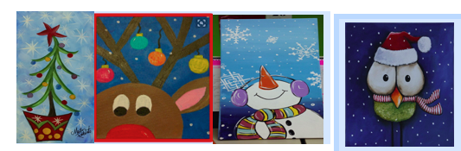

Please complete the following information and return to your student’s teacher by **Thursday, December 7 at 3:00**. No late forms will be accepted.

**BE PROACTIVE**: All participates that return the registration form with money before **Friday, December 1** will be entered into a drawing for a Hazelwood draw string bag!

Students Name: ________________________________________________________________________

Teacher’s Name and grade: ___________________________________________________________

Please mark the number of pictures and write your words in the blank provided.

*We will only write what is listed on this form!!*

***There is a display of the prints in the main lobby of our school.***

________: **Christmas Tree:**

3 words: ______________________________________________________

________: **Reindeer**

3 words: ______________________________________________________

________: **Snowman**

3 words: ______________________________________________________

________: **Christmas Owl**

3 words: ______________________________________________________

Total Number of pictures: ___________Total amount Enclosed: _________________