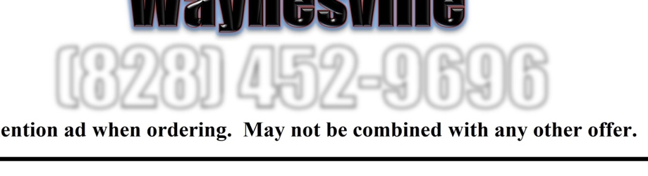
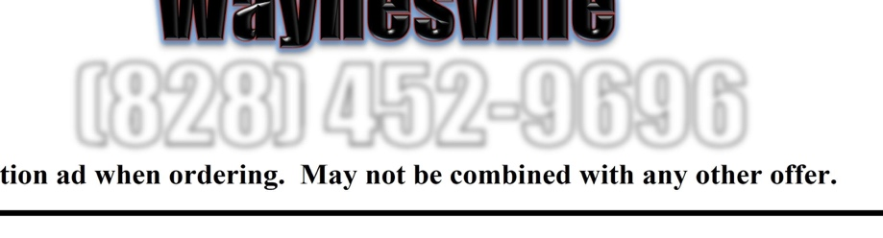

Friday, September 22 , 2017 Friday, September 22 , 2017 10% of All sales between 10% of All sales between

nd

nd
3pm and 9pm will go back to support 3pm and 9pm will go back to support Hazelwood Elementary PTO!!! Hazelwood Elementary PTO !!!
Extra Savings Below Extra Savings Below

1 Large Pizza up to 1 Large 1 Large Pizza up to 1 Large
5Toppings or Any 1 Topping Pizza 5 Toppings or Any 1 Topping Pizza Specialty Pizza (Pickup Only) Specialty Pizza (Pickup Only)
$11 $ 7.99 $ 11 $ 7.99
Promo Code: FR11 Promo Code: FA799 Promo Code: FR11 Promo Code: FA799
Carryout or Delivery Carryout or Delivery

ention ad when ordering. May not be combined with any other offer.

tion ad when ordering. May not be combined with any other offer.

Please m Please men

