ART NEWS

2016 has arrived and we are thrilled to keep building our knowledge about art and everything we have learned so far this year. We have been doing lots of fun things in all grades and here are just a few projects we have been working on.

1st Grade
Self Portraits of us trying to catch snowflakes in our mouths. The students learned about proportion of a human and we talked about expressions.
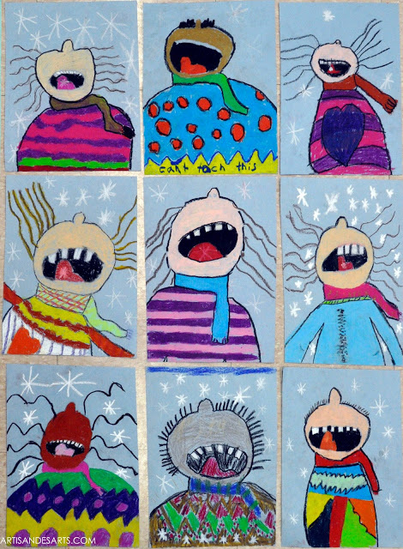

2nd Grade
The students made placemats for a nursing home near us to use at Christmas time. I thought they turned out pretty good! We learned about foreground, middle ground, and background. As well as tints and shades of colors.

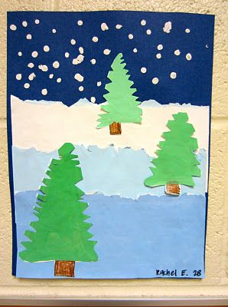

3rd Grade
Cat Study inspired by Laurel Burch. During our study we learned about the artist Laurel Burch and what sort of art she made. We learned about a element of art called patterns. As well as analogous colors.

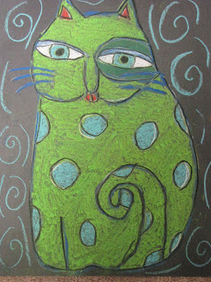

4th Grade
These students learned about an artist named George Rodrigue. A pop artist who didn’t care what people thought about his artwork, he loved making it and became famous by painting what we call the Blue Dog.

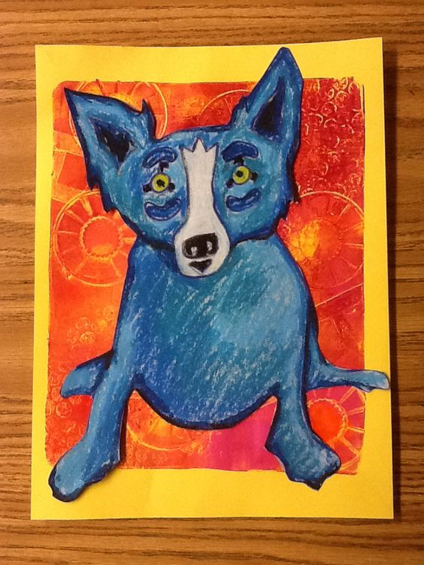
5th Grade
We learned about artist Georgia O’keeffe who painted huge magnified flowers. The students learned about the element of value and how to do different techniques with oil pastels.

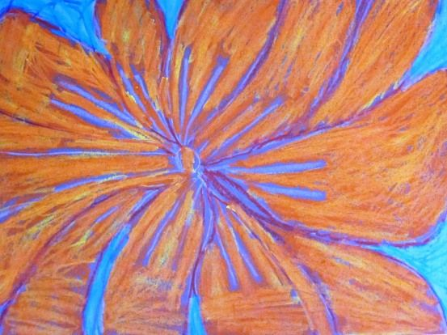

In each grade level now we are starting to work on our Analysis of Student Work (ASW). In each grade level I chose an objective to teach. Then I give a pre-test to determine how much they know about this objective, and most students will not know anything. We will then do a project and learn about the objective I have chosen. I will then give them a post-test in order to determine that they have learned something. I have to submit all of this to the state to show that I am teaching the students what they need to learn.

I would love to hear from you, and you are welcome to stop by the school anytime to say hello, email me, or give me a call.

Jessica Flinchum
Art Teacher

Email – jhauserflinchum@haywood.k12.nc.us

