June CMS Boy’s Basketball Summer Schedule.  Join our Remind Class! Class Code: cmsbear25 | 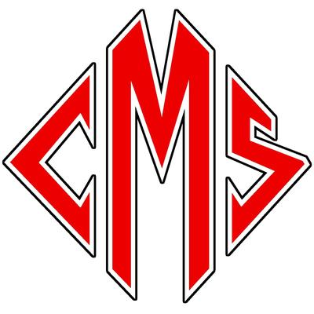
 | 2025
Sunday | Monday | Tuesday | Wednesday | Thursday | Friday | Saturday
1 | 2 | 3 | 4 | 5 | 6 | 7
 | Workouts  6:45-7:45 am | Workouts  7:00-8:00 am | Workouts  7:00-8:00 am | Workouts  7:00-8:00 am | Workouts  7:00-8:00 am
8 | 9 | 10 | 11 | 12 | 13 | 14
 | Workouts  6:45-7:45 am | Workouts  6:45-7:45 am | Workouts  6:45-7:45 am | Workouts  6:45-7:45 am | Scrimmage @ Enka Middle School  3:30 PM
15 | 16 | 17 | 18 | 19 | 20 | 21
 | OFF | OFF | OFF | OFF | OFF
22 | 23 | 24 | 25 | 26 | 27 | 28
 | OFF | OFF | OFF | OFF | OFF
29 | 30
 | OFF

