**3rd Grade AIG – SMART TANK 2020**

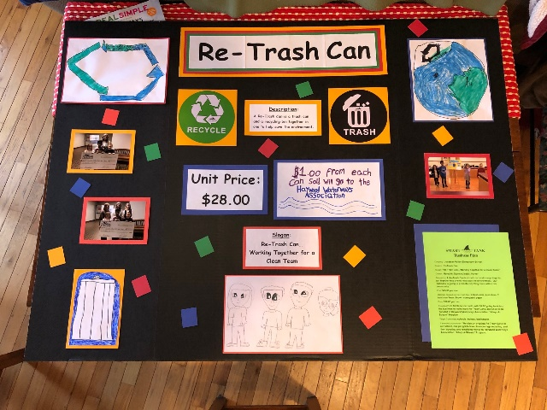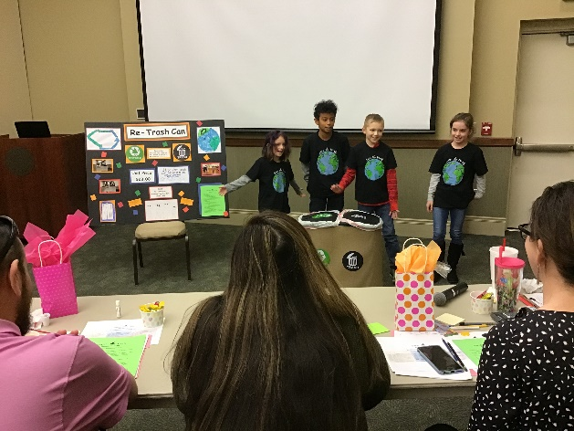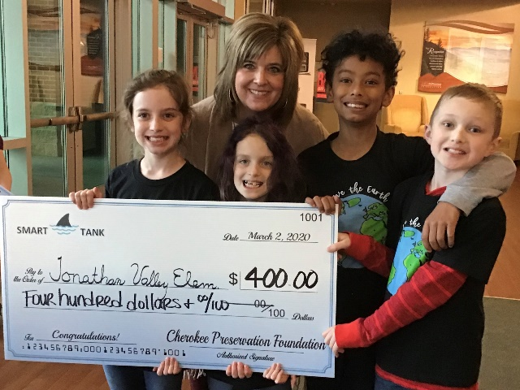 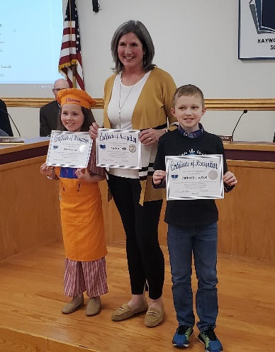

In January the third grade AIG students participated in “Smart Tank”, an entrepreneurship challenge to create a product that would improve the lives of others. Once their group idea was developed, they worked to create a business plan, sample prototype, and presentation that was presented in front of judges. On January 31, each team pitched their creative ideas to local “sharks” for the Haywood County elementary competition held at Clyde Education Center. There were two winning elementary teams tying with the exact same score. Jonathan Valley’s “Re-Trash Can” was one of those teams and was awarded $100 to create a more detailed prototype of their “Re-Trash Can”. Haywood County Schools Foundation awarded an additional $200 grant toward their project.

Their second round was the Western Regional Competition held in Sylva on March 2. At that time, JV’s team of four presented their product idea and prototypes to another panel of regional “sharks”. This time they competed against six other teams of elementary students from Western Carolina districts. They won again and were awarded an additional $400 of

prize money to continue their entrepreneurial journey. They plan to use a portion of this money to create more “Re-Trash Cans” to be donated to local businesses, as well as make a generous monetary donation to Haywood Waterways Association “Adopt-A-Stream” program.

On March 9 JV’s “Re-Trash” team was invited to share their Smart Tank experience at the monthly Haywood County School Board meeting. Parker Livingston was able to attend that night’s meeting and very confidently stood in front of the school board and superintendents to explain his team’s project and journey.