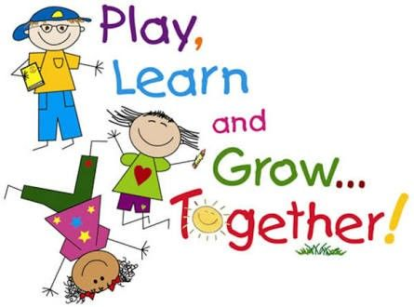

**Clyde Elementary School**

**Supply List**

* Terry cloth bath-size towel or beach towel for nap time (We will **not** be using rest mats this year.)
* Backpack (standard size, no wheels)
* 1 Box of 24 Crayola crayons
* 6 regular glue sticks
* Box of Crayola washable markers
* 1 (4 pack of EXPO dry-erase markers)
* 1 (12 count) package of Ticonderoga #2 pencils
* $7 fee for: 1 1½ 3-ring binder, take-home folder, writing folder, and pencil pouch, marbled composition book (purchased by teacher)