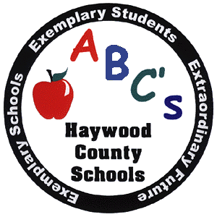 Knox C. Hardin, Director of Secondary Education
Accountability/Testing

Haywood County Schools
1230 North Main Street
Waynesville, North Carolina 28786
828 456-2400 Ext 107
Fax 828 456-2438

TO: Parents and Summer School Students

FROM: Knox C. Hardin, Director of Secondary Education

RE: Summer School - 2010

Summer School Guidelines

- All course offerings in summer school will be for credit recovery purposes only. The courses will be offered online at Central Haywood High School. Students from all four high schools may attend. Online courses will be available for one summer school session (June 21 - July 16) from 8:00 a.m. – 12:00 p.m. or 12:00 p.m.- 4:00 p.m. To register for these online Summer School classes contact Central Haywood High School at 627-9944.
- Credit Recovery for EOC courses is available ONLY if the student achieves Level 3 or 4 on the state EOC test.
- For Non-EOC courses, students must have taken semester/year final exam in the course before being eligible to attend summer school for credit recovery.
- All courses need to be completed by July 16.
- Absences may not exceed two days.
- Two tardies count as one absence.
- Seat license - $50.00 per course - payable when students are registering and refundable upon successful completion of course. (check payable to Central Haywood High School)
- Students will be dismissed from summer school for any misbehavior. Seat license will be nonrefundable if a student is dismissed or withdraws.
- Grades will be determined upon successful completion of summer school.
- Student must have approval from the Principal or Assistant Principal at the student’s base school before enrolling in summer school.

___________________________________ __________________________
Student Signature Date

___________________________________ __________________________
Parent Signature Date

______________________________
Course(s) needed in Summer School

__________________________________
Principal or Assistant Principal Signature (from student’s base school)

