
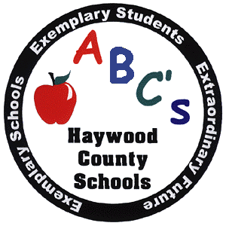Haywood County Schools
1230 North Main Street
Waynesville, NC 28786
828 456 2400
Anne G. Garrett, Ed., D.

Superintendent

STUDENT DRUG TESTING FORM

I desire that _____________________________________ (student) be able to participate in some or all of the following voluntary activities or privileges offered by the Haywood County Schools: interscholastic athletics, other voluntary competitive extracurricular activities, and campus parking privileges. I hereby agree that:

- I have received a copy of the Haywood County Board of Education’s random drug testing policy. I have read and understand the policy.

- _______________________ (student) shall be enrolled in the Haywood County Schools random drug testing program beginning with this school year and may be drug-tested in accordance with the random drug testing policy at any time during his/her enrollment in Haywood County Schools.

- Drug tests of students under the random drug testing policy are completely voluntary and a student is never forced to undergo a drug test. However, a refusal to take a drug test shall result in the student being ineligible to participate in any of the above activities.

- Drug test results may be released to the student, the parent/guardian, the contracted Test Administrator for Haywood County Schools, the Medical Review Officer, the Superintendent’s designee and the student’s school Principal.

Dated: _________________________________________, 20___________.

____________________________________ _____________________________________
Name of Student Name of Parent/Guardian

____________________________________ _____________________________________
Signature of Student Signature of Parent/Guardian

