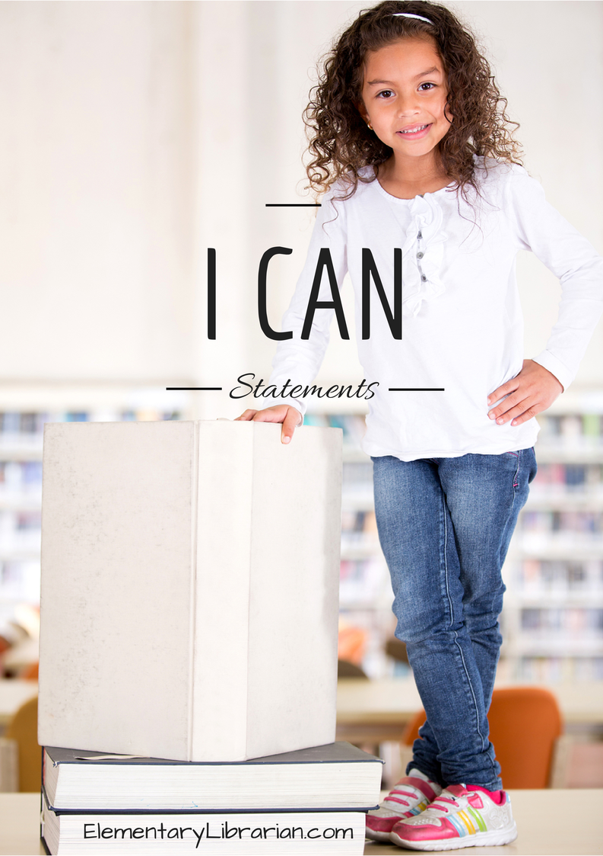

I can describe activities I'd like to do in library class during the school year.

I can follow directions given by my teacher.

I can choose proper book care behaviors.

I can follow library rules. I can follow directions for checking out books.

I can describe this month's library activities.

I can identify a book's characters.

I can identify the parts of a book.

I can describe the job of an author and illustrator.

I can retell a story.

I can retell a story.

I can list facts.

I can tell the difference between fiction books and nonfiction books.

I can describe this month's library activities.

I can sort books into 2 categories: fiction or nonfiction.

I can read sight words.

I can blend sounds to read words.

I can retell a story.

I can retell a story.

I can compare two fiction stories.

I can choose a favorite story.

I can help plan the research project about an ocean animal.

I can name things I'd like to learn about the chosen ocean animal.

I can help my teacher list things I've learned about the chosen ocean animal so far.

I can help my teacher list things I've learned about the chosen ocean animal so far.

I can help my teacher list things I've learned about the chosen ocean animal so far.

I can help my teacher choose the most important facts to include in the research presentation.

I can create a poster about an ocean animal.

I can present facts about an ocean animal to the rest of my class.

I can recognize steps to complete a task.

I can suggest ideas for a how-to book.

I can help write a how-to book.

I can help write a how-to book.

I can describe this month's library activities.

I can put a story in order.

I can put words in ABC order.

I can sort words into their proper categories.

I can describe this month's library activities.

I can describe a poem.

I can name characters, setting, and major events in a story.

I can read sight words.